SOLID

Open Close Principle

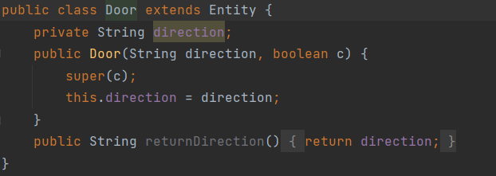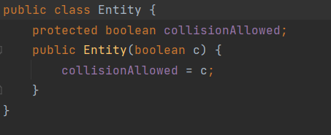

This example came from our source code to introduce entities into our rooms. We will extend the Entity class to create classes that will have a collision relationship with the player. We add functionalities by writing it into the new subclass. As seen in the images, the Door constructor will be based on the Entity constructor, but it will also have a new attribute, direction, to allow the player to enter and exit the room. This is a good example of the Open Close Principle since the Entity class is being extended, but it is not being modified.

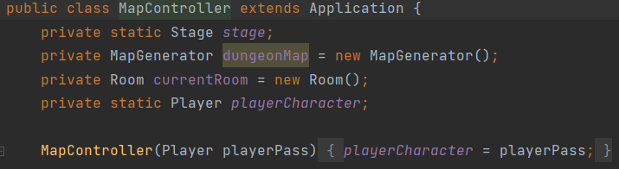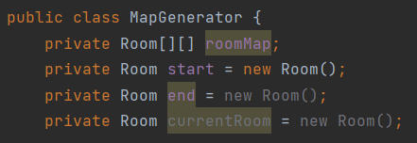Single Responsibility Principle

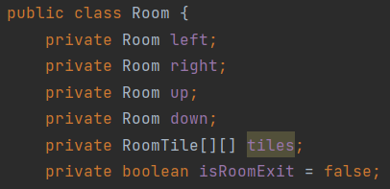The map is based on different types of rooms. For the player to have the ability to move, search, and attack, many different aspects need to be created and implemented. Due to this fact, we created many classes that will be responsible for one single aspect. For example, MapGenerator was made for the sole purpose of generating a map with rooms, based on the Room class, while the MapController is used to set the player’s movement and actions in the map. The Single Responsibility Principle supports this motion. We built our game with numerous small classes with specific names to be responsible for one single responsibility.